Press release 9th of May 2017

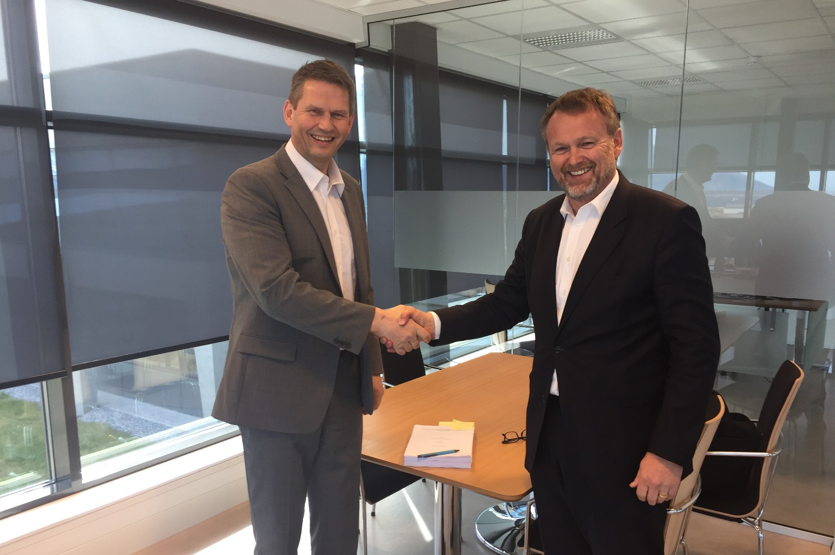
Peder Stette (EVP & CTO Optimar) and Webjørn Eikrem (EVP Harvesting, Production and Supply Chain, Aker Biomarine).

Optimar to deliver krill factory to Aker BioMarine
Optimar has signed a contract with Aker BioMarine to supply a complete krill factory for Aker BioMarine's new krill fishing vessel. The ship will be built by Vard and is scheduled for delivery by Vard Brattvåg in November of 2018. The catch capacity of the vessel will be an impressive 1,300 tonnes per day and it will have a processing capacity of 200 tonnes of meal per day. By way of comparison, the maximum catch capacity of the most efficient krill fishing vessel currently operating is 1,000 tonnes per day. Optimar's role will be that of systems integrator, and the company will have overall responsibility for the entire factory delivery.

The first vessel designed specifically for processing krill
This is the first vessel to be built exclusively for krill production. Building a new, specially-designed krill fishing vessel offers a unique opportunity to apply new ideas at all stages of the process. Saving energy and reducing the operation’s environmental footprint were among the most important areas of focus when the new vessel was being planned.
Aker’s new krill trawler will be equipped with control systems from Optimar that allow the factory to be kept constantly at peak operating efficiency by means of continuous measurement and analysis. Furthermore, the vessel will be fitted with energy-saving equipment that reuses energy throughout the entire processing cycle. For example, heat from one part of the process will be reused elsewhere in the process. After boiling, the krill are decanted (solids and liquid having been separated) and the solids undergo further drying to produce krill meal. The factory has the capacity to produce 200 tonnes of meal a day.

Development of the concept
Optimar is a longstanding collaborator with both Vard and Aker, and has supplied products and solutions to both companies.
On this project, Optimar worked closely with experts from Vard and Aker BioMarine over a period of several months to find the best solutions for the new vessel. Thorough analyses and calculations were performed on efficiency and energy-saving measures for the factory. The state-of-the-art facility will be equipped with the latest meal production equipment and a control system that offers an unparalleled level of control. Operating parameters will be logged continuously to maximise the quality and traceability of the product. All historical data can be processed to optimise operations in terms of quality and energy economy, and preventive service procedures can also be developed. The risk of downtime is reduced by remote servicing from on shore, with Aker BioMarine’s new control centre providing services 24/7.
The contract is worth in the region of NOK 300 million to Optimar, and it will consolidate the company’s position as a leading supplier to the fisheries industry.
About Optimar
Optimar is a leading supplier and systems integrator of automated factory solutions to the maritime and seafood sector throughout the world. Having undergone substantial growth in recent years, the company now has divisions in Norway, Spain and the United States. Headquartered in the municipality of Giske, a few kilometres outside Ålesund in Norway, Optimar has some 300 employees and in 2016 reported sales of NOK 650 million.

